Analysis

Use Case Diagram

Definition: A use case diagram is a graphic depiction of the interactions among the elements of a system.

A use case is a methodology used in system analysis to identify, clarify, and organize system requirements. In this context, the term "system" refers to something being developed or operated, such as a mail-order product sales and service Website. Use case diagrams are employed in UML (Unified Modeling Language), a standard notation for the modeling of real-world objects and systems.

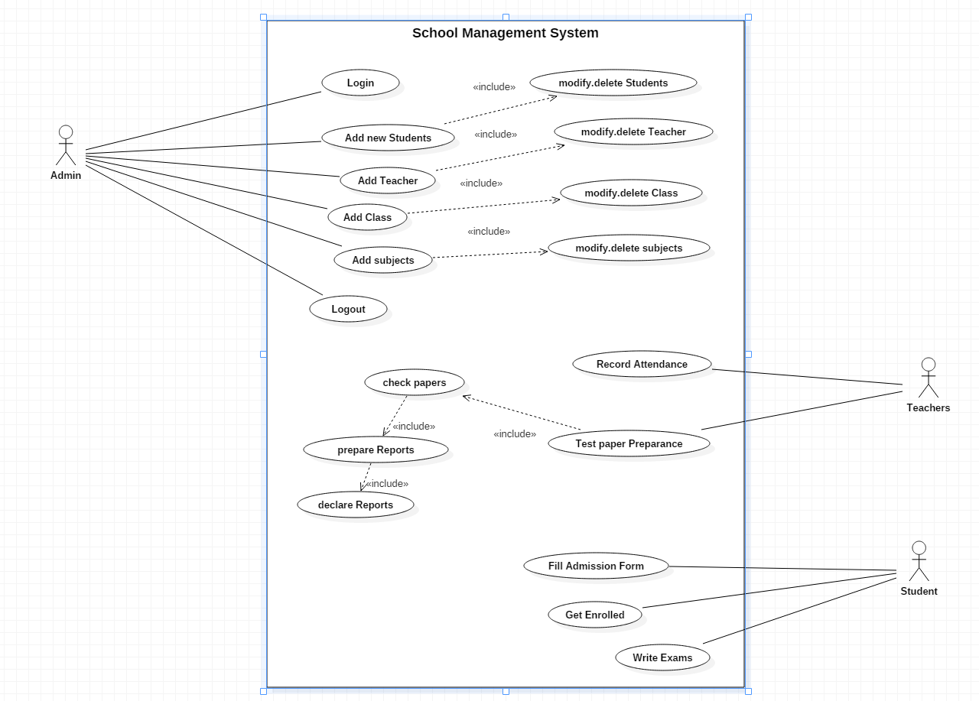

Fig: Use case diagram for School Management System

Justification: A use case is a methodology used in system analysis to identify, clarify, and organize system requirements. The use case is made up of a set of possible sequences of interactions between systems and users in a particular environment and related to a particular goal.

Initial Class Diagram

Definition: class diagram to show the classes and relationships. A class diagram shows classes, the relationships between classes, constraints, and attributes of classes. The diagram is helpful in designing and building a system because it can be used as the blueprint for the final product.

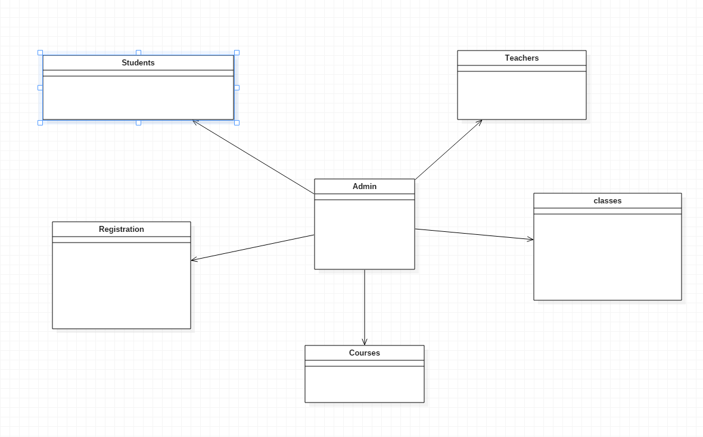

Fig: Initial Class Diagram

ER diagram for School Management System

Definition: An entity-relationship diagram (ERD) is a data modeling technique that graphically illustrates an information system's entities and the relationships between those entities. An ERD is a conceptual and representational model of data used to represent the entity framework infrastructure.

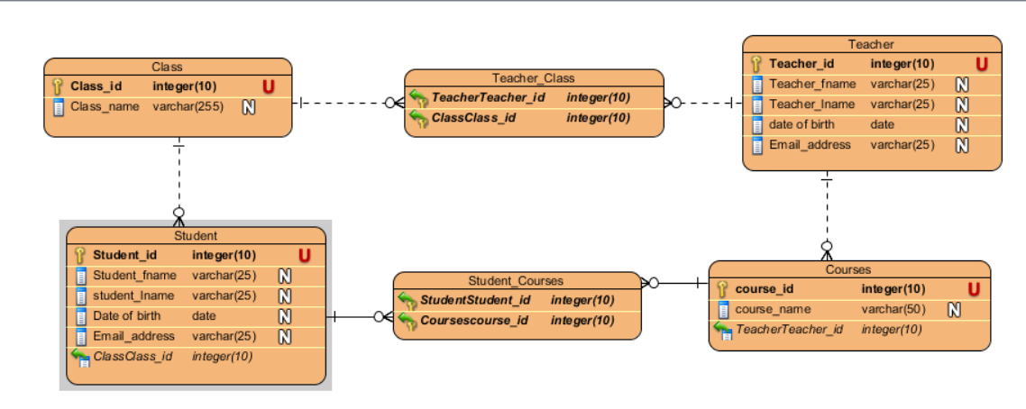

Fig: ER Diagram

Justification: ER diagrams are used to analyze existing databases to find and resolve problems in logic or deployment. Drawing the diagram should reveal where it's going wrong. Business information systems: The diagrams are used to design or analyze relational databases used in business processes.

Functional and non-functional requirement for School Management System

Functional requirement:Functional requirements are those which are related to the technical functionality of the system

Non-functional requirement: It is a requirement that specifies criteria that can be used to judge the operation of a system in particular conditions, rather than specific behaviors.

|  |  |  |
| --- | --- | --- |
| Functional(F)/Non-functional(NF) | Requirements | MoSCoW |
| NF(R1) | Login | M |
| NF(R2) | Registration | M |
| F(R3) | Admission Process | M |
| F(R4) | Update Information | S |
| F(R5) | Delete Information | C |
| F(R6) | Retrieve Information | S |
| F(R7) | Create Information | S |
| NF(R8) | Fees Information | S |
| NF(R9) | Teacher Information | S |
| NF(R10) | Student Information | M |
| F(R11) | Routines | M |
| F(R12) | Results | M |
| F(R13) | Laboratory | M |
| F(R14) | Salary | M |
| NF(R15) | Calendar | S |

Functional and Non-functional Requirements of School Management System

UI Design for School Management System

Homepage

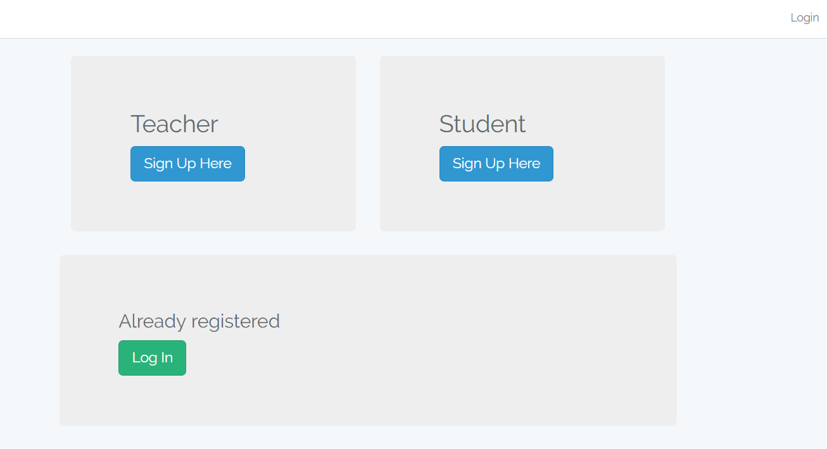

Fig: homepage for school management system

Registration for Teachers

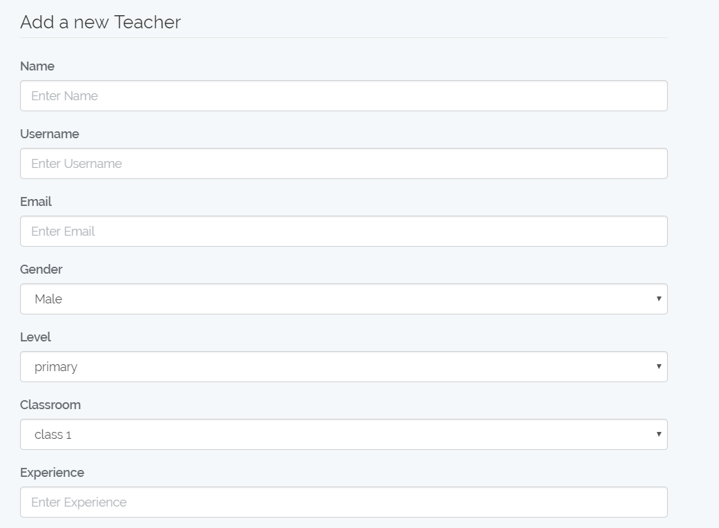

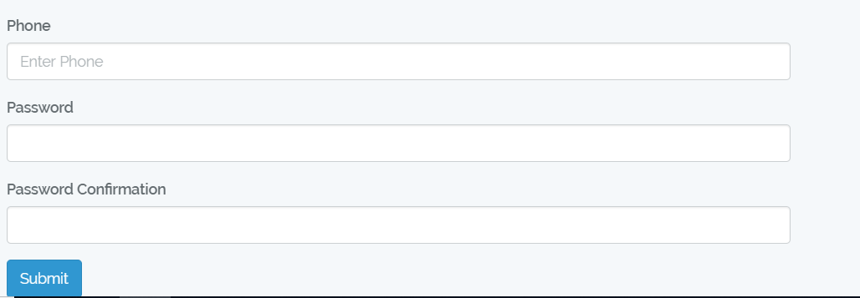

Fig: Registration Form

Registration for students

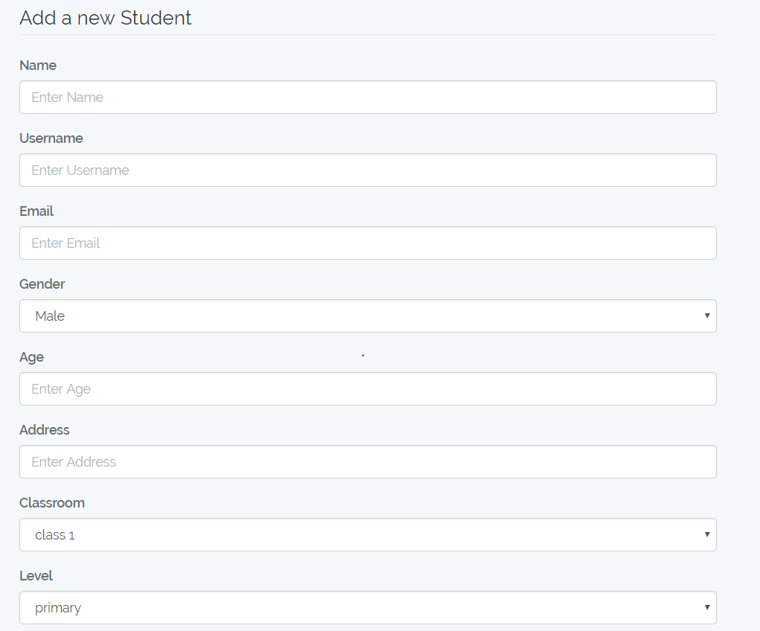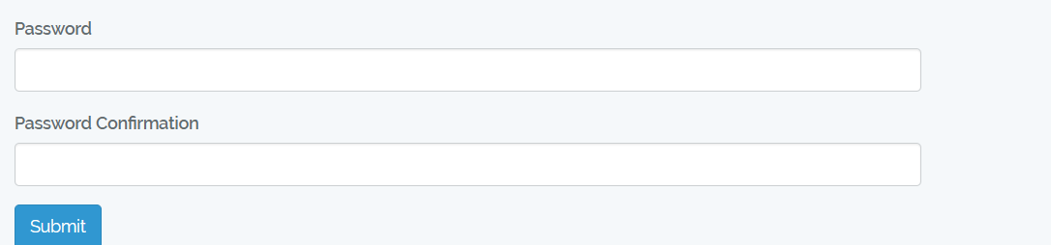

Fig: Registration form for student

Login form for both admin and users

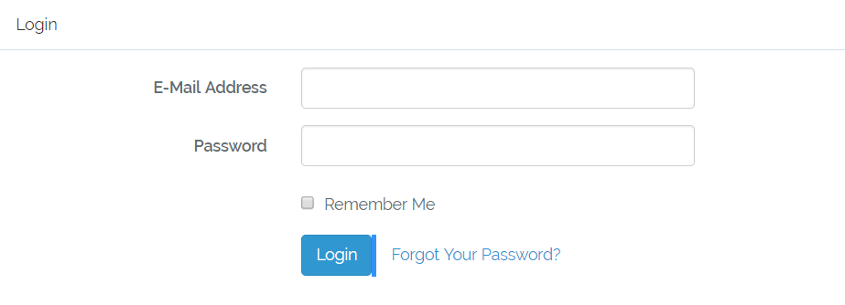

Fig: login form

Dashboard of admin

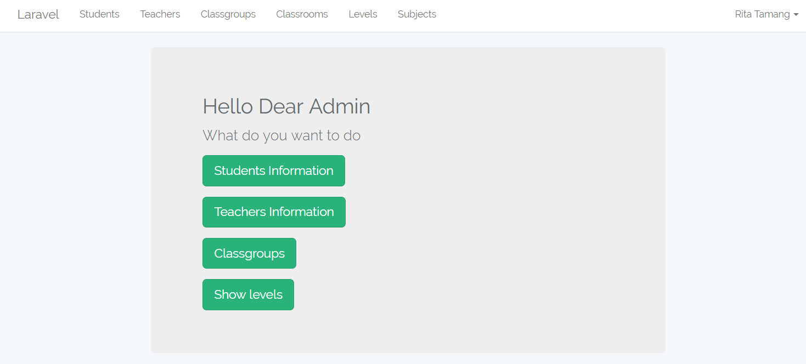

Fig: admin dashboard

**Design**

**Class diagram**

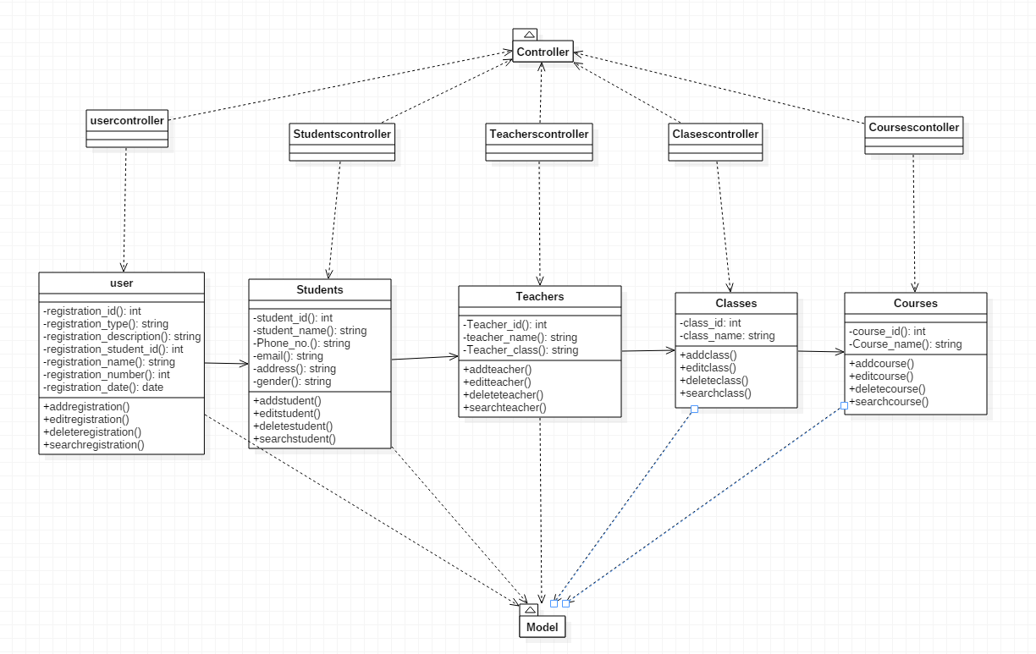

Fig: Class Diagram

Justification: A class diagram is an illustration of the relationships and [source code](https://searchmicroservices.techtarget.com/definition/source-code) dependencies among classes in the Unified Modeling Language (UML). In this context, a [class](https://whatis.techtarget.com/definition/class) defines the [method](https://whatis.techtarget.com/definition/method)s and [variable](https://whatis.techtarget.com/definition/variable)s in an object, which is a specific entity in a program or the unit of code representing that entity. Class diagrams are useful in all forms of object-oriented programming (OOP). The concept is several years old but has been refined as OOP modeling paradigms have evolved.

Activity Diagram

Definition

Activity diagram**:** An activity diagram visually presents a series of actions or flow of control in a system similar to a flowchart or a data flow diagram. Activity diagrams are often used in business process modeling. They can also describe the steps in a use case diagram. Activities modeled can be sequential and concurrent.

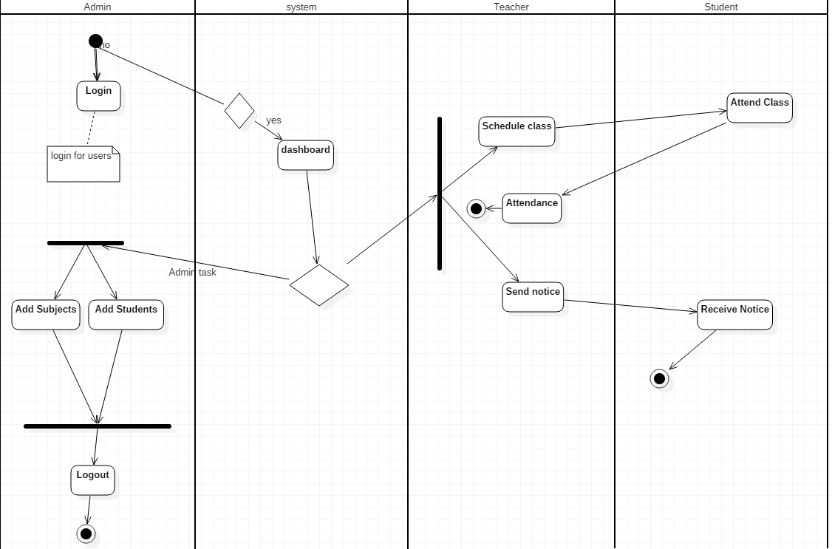

Fig: Diagram of activity diagram

Justification**:** Purpose of Activity Diagrams. The basic purposes of activity diagramsis similar to other four diagrams. It captures the dynamic behavior of the system. Other four diagrams are used to show the message flow from one object to another but activity diagram is used to show message flow from one activity to another

Design

Class diagram



Fig: Class Diagram

Justification: A class diagram is an illustration of the relationships and [source code](https://searchmicroservices.techtarget.com/definition/source-code) dependencies among classes in the Unified Modeling Language (UML). In this context, a [class](https://whatis.techtarget.com/definition/class) defines the [method](https://whatis.techtarget.com/definition/method)s and [variable](https://whatis.techtarget.com/definition/variable)s in an object, which is a specific entity in a program or the unit of code representing that entity. Class diagrams are useful in all forms of object-oriented programming (OOP). The concept is several years old but has been refined as OOP modeling paradigms have evolved.

Activity Diagram

Definition

Activity diagram**:** An activity diagram visually presents a series of actions or flow of control in a system similar to a flowchart or a data flow diagram. Activity diagrams are often used in business process modeling. They can also describe the steps in a use case diagram. Activities modeled can be sequential and concurrent.



Fig: Diagram of activity diagram

Justification**:** Purpose of Activity Diagrams. The basic purposes of activity diagramsis similar to other four diagrams. It captures the dynamic behavior of the system. Other four diagrams are used to show the message flow from one object to another but activity diagram is used to show message flow from one activity to another.

Sequence diagram: A sequence diagram simply depicts interaction between objects in a sequential order i.e. the order in which these interactions take place. We can also use the terms event diagrams or event scenarios to refer to a sequence diagram. Sequencediagrams describe how and in what order the objects in a system function.

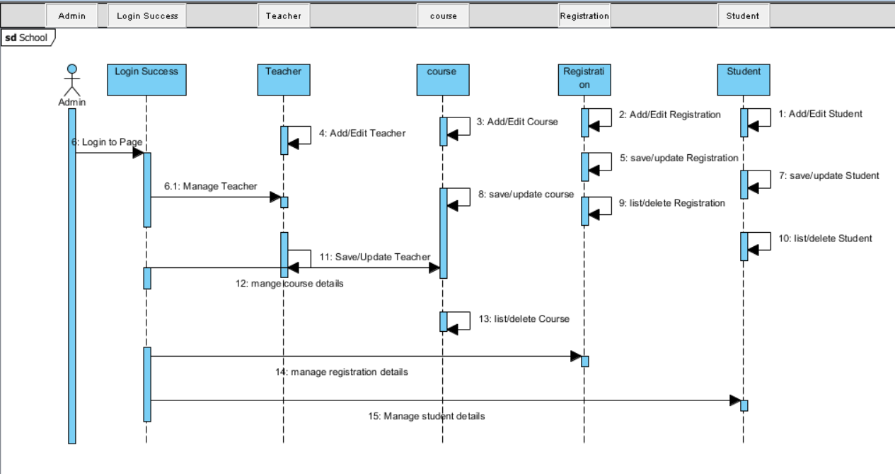

Fig: sequence diagram

Justification: A sequence diagram shows object interactions arranged in time sequence. It depicts the objects and classes involved in the scenario and the sequence of messages exchanged between the objects needed to carry out the functionality of the scenario. Sequence diagrams are sometimes called event diagrams or event scenarios.

Initial class diagram for school management system

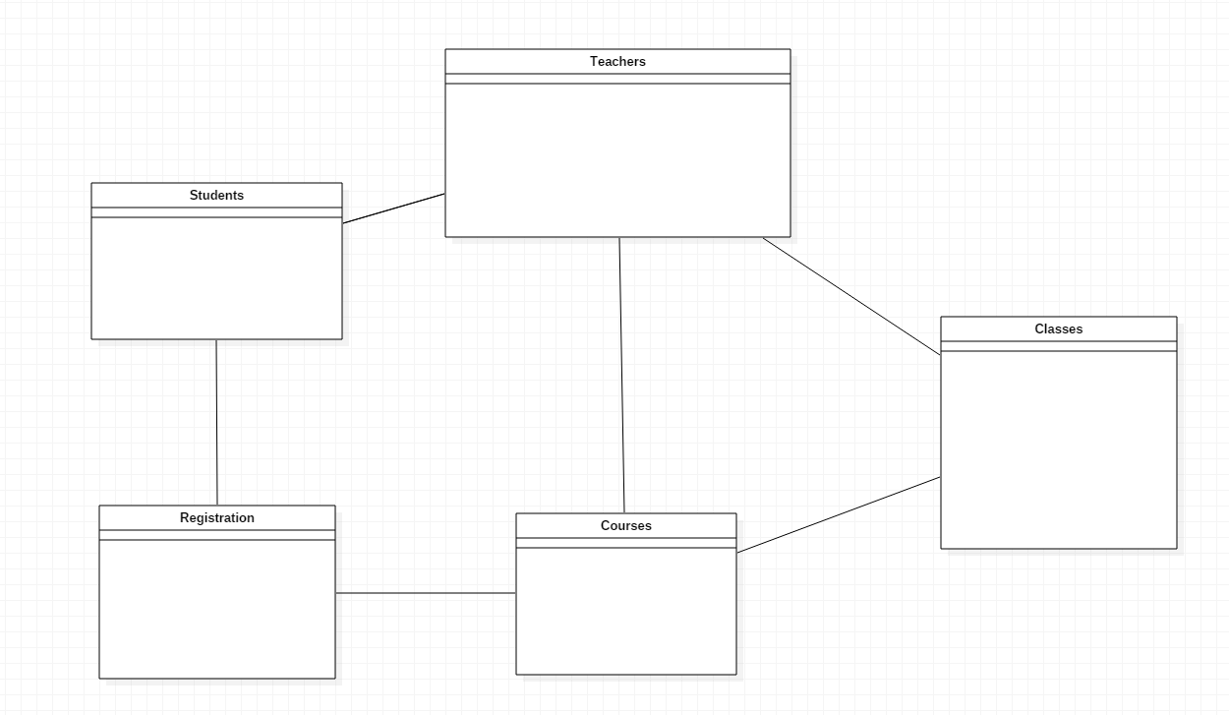

Use case diagram for school management system





ER diagram for school management system